**Word Cloud by Python**

1. **Abstract :**

Word cloud using python basically deals with python coding, but the end result is something interesting and something attractive. Today's project is going to take some text from one of our saved files and then generate it to wordcloud, later play with it, plus changing colors, also removing stop words and saving in wordcloud to the file. We used Jupyter notebook to code and the language used is python. The website looks more interesting after adding wordcloud. We will know more about data visualisations, also how useful it is and how can we code it ? We will know about each statement and it’s meaning. Most importantly, we will come to know what is wordcloud actually? It may help websites look more technologically advanced in future.



1. **Introduction:**

Word clouds (also known as text clouds or tag clouds) work in a simple way: the more a specific word appears in a source of textual data. In other words, word Cloud is a data visualization technique used for representing text data in which the size of each word indicates its frequency or importance. Significant textual data points can be highlighted using a word cloud. Word clouds are widely used for analyzing data from social network websites.

A word cloud is a collection, or cluster, of words depicted in different sizes. The bigger and bolder the word appears, the more often it’s mentioned within a given text and the more important it is. Data visualisation is the communication of data in a visual manner, or turning raw data into insights that can be easily interpreted by your readers { In other words, data visualization refers to the techniques used to communicate data or information by encoding it as visual objects (points, lines or bars) contained in graphics}.

Now we know why word clouds are important? For our word cloud coding we just need a jupyter notebook as we are going to code this using python. if we are going to the normal process ( like through your downloaded compiler or terminal) we would have to download a few packages like numpy, matplotlib , pandas , pillow and word cloud. The numpy library is one of the most popular and helpful libraries that is used for handling multi-dimensional arrays and matrices. It is also used in combination with Pandas library to perform data analysis. Python os- module is built in the library so no need to install it. For visualization, matplotlib is a basic library that enables many other libraries to run and plot on its base includingseaborn or wordcloud that you will use in this tutorial. The pillow library is a package that enables image reading. Pillow is a wrapper for PIL - Python Imaging Library. You will need this library to read in image as the mask for the wordcloud. we’ll be using get_from_frequencies function.

1. **Existing System Architecture/Working:**

We usually have lots of books to read either by interest or from different sources. Reading is fun but sometimes it depends on mood too whether it cooperates or not. Also, there are important pdfs and long scripts to read. The thing which matters the most and that is to be highlighted is the important parts. In layman method it goes like: reading the whole paras word to word, going through it twice thrice to understand the crucks and then noting down the things. Reading all the content, be it from book, pdf, script anything manually is quite difficult and time consuming. Instead of the tedious process, wordcloud is the software or program rather to be used. To reduce the wastage of time or the tough efforts at urgent cases wordcloud is introduced.

1. **Problem Definition:**
2. Problem Identification in current scenario in specific, clear understandable wordings.
3. Usually we use a wordcloud generator for making a wordcloud. But, the question comes why do we use it ? The reasons are : Understanding Client Issues (How are you currently analyzing your customer satisfaction levels? From polls and surveys to social media posts and more, your audience is talking about your brand. As they do so, they’re delivering valuable insights into the psyche of your target customer. What’s making them tick and what to do they love? Are there any issues that seem to pop up time and again?)
4. Quickening Business Actions (when you are out of time you can copy the text into the generator and let it do its job, you can see in seconds which talking points appear the most frequently. Then, you’ll know where to start your search to hit the most important parts)
5. Analyzing Employee Sentiment (When you want your employee to share feedback something , through cloud visualisation you’re able to see which points your employees are discussing at the highest rate, you’ll know how to make valuable and meaningful changes that can boost morale, strengthen company culture, and improve performance.)
6. Simplifying Technical Data ( for technical research or findings , when you present a wordcloud instead, you’re able to share the same findings in a more accessible and engaging way. This expands your reach and enables you to share important information in a way that doesn’t require advanced technical understanding.)
7. Searching for Patterns in Data (With quantitative data, charts, graphs, and other data visualizations can help you identify key patterns. However, pulling these same insights from qualitative data can prove cumbersome at best and impossible at worst.These would be difficult to find in a tabular format, but they pop out in a word cloud.)
8. Search Engine Optimization (You can use a word cloud generator to see how your content appears to Google bots and similar machines. While it won’t reveal the more technical elements of SEO i.e. Search Engine Optimization such as headers, backlinks, and alt tags, it does help you see the general message that your page conveys. This is important because when Google “looks” at your page, it does so by scanning its content and code).

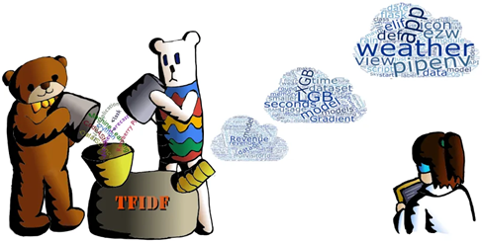

1. **Objective**:
2. Word clouds are an easy to use and inexpensive option for visualizing text data.
3. They are most commonly used to highlight popular or trending terms based on frequency of use and prominence.
4. A word cloud is a beautiful, informative image that communicates much in a single glance.
5. For business purposes, word clouds can help you find your customers’ pain points. If you collect feedback from your customers, you can generate a word cloud using customers’ language to help identify what is most important to them.
6. Word clouds are an interesting way of visualizing data.
7. Simple to understand.
8. **Proposed System Architecture/Working:**

As the jupyter notebook is used for this project. The first step is the displaying of the image then the image text is converted to just text and stored under a variable. Now, that variable undergoes the whole process to get the output as wordcloud. The process involves a few library's importation which helps to get the output. Giving the inputs in image or a text format and getting the desired output which is an image containing the words which are most repeated in the input which is given that may be image or text format.

When the input is given in the text format we upload a file which is a text file. Each and every word of the text file is separated, stored and count is taken. While giving the input in the image format the image is first scanned and all the words are converted in a text format. After the conversion into the text format the words are separated, stored and count is taken. Upon successful completion of taking the input in image or text format we get the desired output which is in the image format and the word which is repeated the most or having the highest frequency are displayed the boldest and largest in size. Size of words keeps decreasing as their frequency goes on decreasing.

1. **Technology Stack:**
2. Jupyter notebook is used as a software.
3. In technology, we need Python coding language knowledge.
4. If you use normal python terminals (example: pycharm etc..) you need to install required numpy, matplotlib, wordcord library versions through coding in your terminals.
5. **Implementation**

**OUTPUT:**

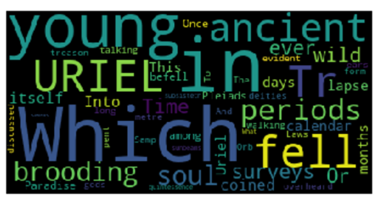

As we can see lots of words inside this rectangular layout that is what the magic of wordcloud we tried the same using text file (.txt) and now we are with a image file (.jpg) and the output is all above.

1. **Conclusion:**

**The summary to this would be :**

1. It also focuses on data visualisation and its meaning with
2. We used a jupyter notebook for this with python as a coding language.
3. The code involves installation and importing of libraries, also the algorithm for the code is defined really well.
4. This wordcloud not only gives an attractive look but also highlights the important words or the most repetitive word in that image or text.